New Loadbook Options

The latest release of the Loadbook tool includes new search options. With the latest upgrade, it is still possible to perform previous specific Item/Description searches using the ‘Equal To’ drop-down option, as well as utilize additional search features such as ‘Not Equal To’, ‘Like’ and ‘Not Like’. The searches will review a customer’s purchase history to reveal what they have, based on the search parameters chosen.

The ‘Equal To’ drop-down option will allow you to search for customers in your loadbook which have purchased specific coins. For example,
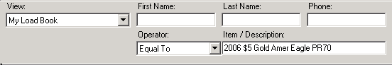
would result in displaying all customers who have purchased the
‘2006 $5 Gold Amer Eagle PR70’ coin.

If a customer did not purchase the coin, they would not be listed.

Likewise, a ‘Not Equal To’ option will allow you to search for customers who have not purchased a specific coin.
For example,
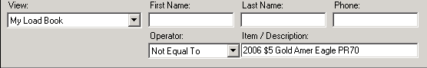
Note: These 2 drop-down choices are a specific search options. The possibility remains that customer may or may not possess specific coins based on the exact spelling.

For a more general search, the ‘Like’ and ‘Not Like’ drop-down options can be chosen. In order to properly and fully utilize the new features, additional steps will need to be performed. Specifically, in order to correctly search for coins using the ‘Like’ and ‘Not Like’ drop-down options, the search parameter entered needs to be enclosed in %’s. If these symbols are not used, erroneous data will be returned. For example,
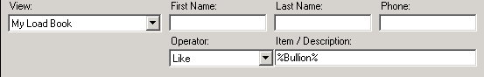
would result in displaying all customers who have purchased
‘Bullion’ coins.

Likewise, to search for customers who have not purchased bullion, you will need to choose ‘Not Like’ and enter ‘%Bullion%’ into the search box.
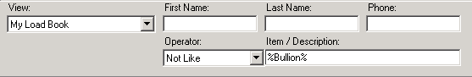
Note: These advanced searches will take longer to perform.

Please contact IT if you have further questions or if you notice any anomalies that occur during your searches.

